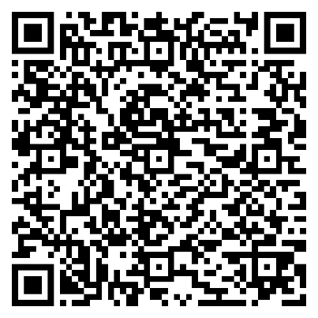
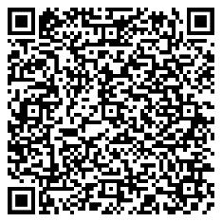
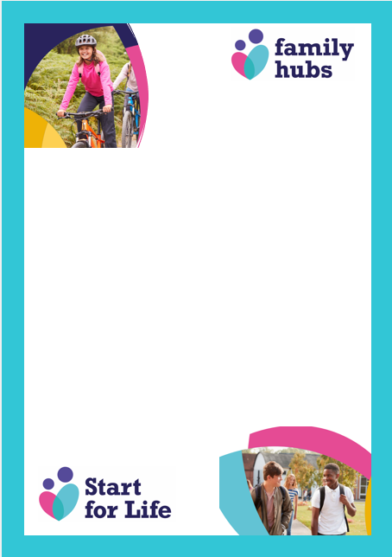
Family Hub
Shrublands Centre, Magdalen way,
Great Yarmouth NR31 7BP
01493448318
https://norfolk.gov.uk/40406
Please do remember that if you find yourself or your child struggling or needing some support Family Hubs are easily accessible to access in person, by telephone or via our website. Please don’t hesitate to contact us for support, information & guidance.
Norfolk County Council – Thinking about… “Preparing for change”

Try out these QR codes provided by Norfolk County Council, to enhance your child’s journey of starting school.
Norfolk County council – Ideas to… “Help your child feel positive about starting school”

Remember keep strong! Your children will be looking to you to see how to react. It is normal for you to feel emotional too but try to keep that under wraps until they get through the door. Wave, smile and tell them you’ll see them later.
Ready for School Tips and Tricks ….

